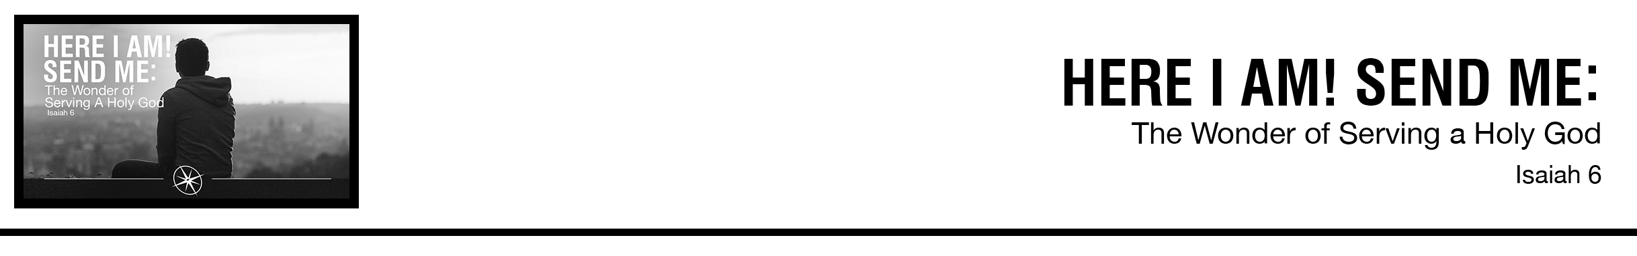Description: confused 02

***1*** *In the year that King Uzziah died I saw the Lord sitting upon a throne, high and lifted up; and the train of his robe filled the temple.* ***2****Above him stood the seraphim. Each had six wings: with two he covered his face, and with two he covered his feet, and with two he flew.* ***3****And one called to another and said: “Holy, holy, holy is the LORD of hosts; the whole earth is full of his glory!”* ***4****And the foundations of the thresholds shook at the voice of him who called, and the house was filled with smoke.* ***5****And I said: “Woe is me! For I am lost; for I am a man of unclean lips, and I dwell in the midst of a people of unclean lips; for my eyes have seen the King, the LORD of hosts!”* ***6****Then one of the seraphim flew to me, having in his hand a burning coal that he had taken with tongs from the altar.* ***7****And he touched my mouth and said: “Behold, this has touched your lips; your guilt is taken away, and your sin atoned for.”* ***8****And I heard the voice of the Lord saying, “Whom shall I send, and who will go for us?” Then I said, “Here I am! Send me.”* ***9****And he said, “Go, and say to this people: “ ‘Keep on hearing, but do not understand; keep on seeing, but do not perceive.’*

***10*** *Make the heart of this people dull, and their ears heavy, and blind their eyes; lest they see with their eyes, and hear with their ears, and understand with their hearts, and turn and be healed.”* ***11*** *Then I said, “How long, O Lord?” And he said: “Until cities lie waste without inhabitant, and houses without people, and the land is a desolate waste,* ***12*** *and the LORD removes people far away, and the forsaken places are many in the midst of the land.* ***13*** *And though a tenth remain in it, it will be burned again, like a terebinth or an oak, whose stump remains when it is felled.” The holy seed is its stump.* *(ESV)*

Ben Blakey • Compass Bible Church • August 11 & 12, 2018 • Msg. # G18-08

**1. ___________________________________**

**2. ______________________________________**

**3. ________________________________________**

**4. _____________________________________**

**Application Questions**

*These questions are provided for your further study and application of today’s sermon. Thoughtfully writing out the answers to these questions will help to drive home the point of today’s study. It is also helpful when you are able to discuss your answers with others. For more information about small groups at Compass Bible Church that utilize these questions as the basis for their weekly discussion, please call the church office at (949) 540-0699 or email us at SmallGroups@CompassChurch.org.*

1. The 3rd distinctive of Compass Bible Church is “We seek to maintain a high view of God.” Why do you think that a low view of God is so prevalent in our day and age? What can you personally do this week to maintain a high view of God?

2. Read **Psalm 32:1-2.** How would you explain to an unbeliever why forgiveness is such a great cause for joy to a Christian? Do you think your life accurately reflects that kind of joy?

3. Read **Psalm 32:3-5.** What role did the conviction of sin play in your conversion story? How might that memory affect your own evangelistic efforts towards others?

4. Read **Colossians 4:3-6.** How would you like to see yourself grow in the area of personal evangelism over this next year?

*This Week’s  
Bible Reading Schedule*

**August 12th**

*Ps.93-95 & Ro.11:22-36*

**August 13th**

*Ps.96-98 & Ro.12*

**August 14th**

*Ps.99-102 & Ro.13*

**August 15th**

*Ps.103-104 & Ro.14*

**August 16th**

*Ps.105-106 & Ro.15:1-20*

**August 17th**

*Ps.107-108 & Ro.15:21-33*

**August 18th**

*Ps.109-111 & Ro.16*

**August 19th**

*Ps.112-115 & 1Cor.1*

*2*

5. Read **2 Timothy 3:12-13**. Despite this sobering warning about the future, what are some reasons Christians should be encouraged to press on in ministry and evangelism?