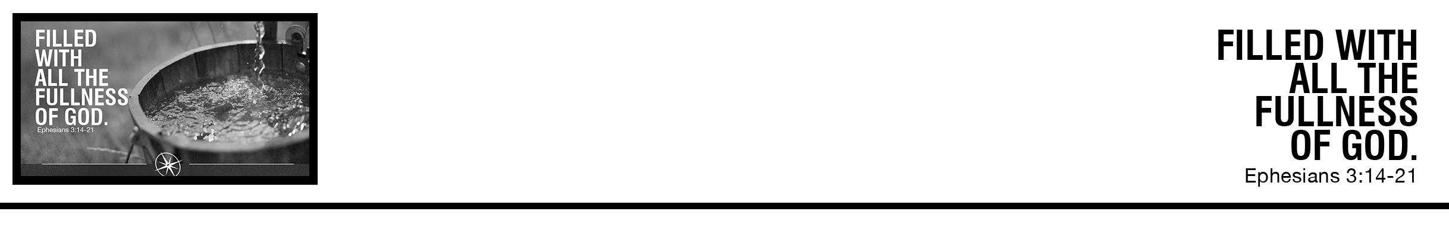Description: confused 02

Dr. Jeremy Kimble • Compass Bible Church • August 5 & 6, 2017 • Msg. # G17-08

***14****For this reason I bow my knees before the Father,****15****from whom every family in heaven and on earth is named,****16*** *that according to the riches of his glory he may grant you to be strengthened with power through his Spirit in your inner being,****17****so that Christ may dwell in your hearts through faith—that you, being rooted and grounded in love,****18****may have strength to comprehend with all the saints what is the breadth and length and height and depth,****19*** *and to know the love of Christ that surpasses knowledge, that you may be filled with all the fullness of God.* ***20*** *Now to him who is able to do far more abundantly than all that we ask or think, according to the power at work within us,****21*** *to him be glory in the church and in Christ Jesus throughout all generations, forever and ever. Amen* (ESV)

***Notes:***

**Application Questions**

*These questions are provided for your further study and application of today’s sermon. Thoughtfully writing out the answers to these questions will help to drive home the point of today’s study. It is also helpful when you are able to discuss your answers with others. For more information about small groups at Compass Bible Church that utilize these questions as the basis for their weekly discussion, please call the church office at (949) 540-0699 or email us at SmallGroups@CompassChurch.org.*

1. What do your prayer requests typically consist of?

2. How does reading prayers expressed in the Bible encourage you to change/enhance your own prayer life?

3. Many times people think of the power of the Spirit consisting of sign gifts and miracles, but here we see it as empowerment for Christ to take up residence and effect life-change as we submit to him. Are you praying for that kind of power? If so, what kinds of specific changes might you expect to see in your life (i.e., sin to confess, virtue to be pursued)? If you need help thinking of specifics, read **Ephesians 4-6** or **Colossians 3:1-17**.

4. Think about the love of God displayed in Christ for you. As you consider the details of the gospel, how does that shape your own love and affection for God and others?

*This Week’s  
Bible Reading Schedule*

**August 6th**

*Ps.78 & Ro.7*

**August 7th**

*Ps.79-81 & Ro.8:1-18*

**August 8th**

*Ps.82-84 & Ro.8:19-39*

**August 9th**

*Ps.85-87 & Ro.9*

**August 10th**

*Ps.88-89 & Ro.10*

**August 11th**

*Ps.90-92 & Ro.11:1-21*

**August 12th**

*Ps.93-95 & Ro.11:22-36*

**August 13th**

*Ps.96-98 & Ro.12*

5. When you pray, do you come with a heart expecting the God who has infinite resources to do abundantly more than all that you could ask or think in your life, your family, your friends, the church, and in the world? (*remember the context:* God will empower us with His Spirit, so Christ can reside in our hearts, so we can know his love, and be filled with his fullness)