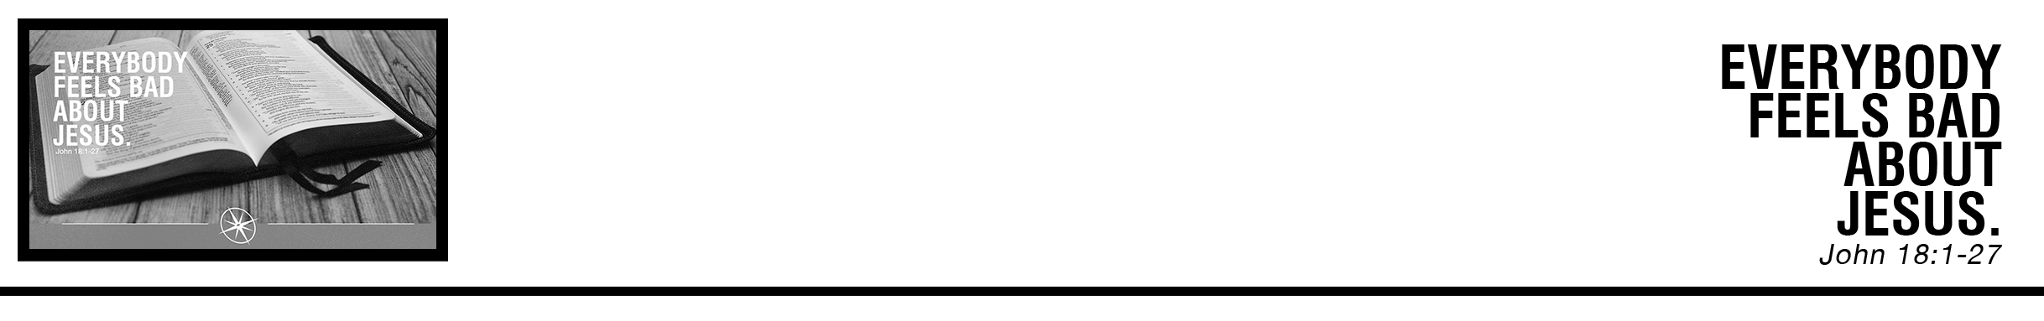Description: confused 02

Bobby Blakey • Compass Bible Church • September 16 & 17, 2017 • Msg. # G17-11

**1. Understand ________________________________________**

**2. Pray ____________________________**

**3. Share ____________________________________**

**Application Questions**

*These questions are provided for your further study and application of today’s sermon. Thoughtfully writing out the answers to these questions will help to drive home the point of today’s study. It is also helpful when you are able to discuss your answers with others. For more information about small groups at Compass Bible Church that utilize these questions as the basis for their weekly discussion, please call the church office at (949) 540-0699 or email us at SmallGroups@CompassChurch.org.*

1. Have you ever heard people say that they are Christians because they feel bad about their sin? Have you thought this?

Read **Matthew 27:3-5.**How does Judas’ response to betraying Jesus sound similar to the way we talk about confessing our sins today?  What is Judas missing?

2. Read **2 Corinthians 7:10-11.**Have you just regretted your sin, or have you repented of it?  What has this “godly grief” looked like in your life?

3. Read **Matthew 6:12-13.**How does Jesus’ example in these verses compare with the way you pray? Do you ask for forgiveness of past sins only?  Do you also pray for deliverance from future temptations?

*This Week’s  
Bible Reading Schedule*

**September 17th**

*Ecc.1-3 & 2Cor.9*

**September 18th**

*Ecc.4-6 & 2Cor.10*

**September 19th**

*Ecc.7-9 & 2Cor.11:1-15*

**September 20th**

*Ecc.10-12 & 2Cor.11:16-33*

**September 21st**

*Song 1-3 & 2Cor.12*

**September 22nd**

*Song 4-5 & 2Cor.13*

**September 23rd**

*Song 6-8 & Gal.1*

**September 24th**

*Is.1-3 & Gal.22*

4. Read **Acts 4:8-13.**How does Peter's confession prove him innocent from his sin of denying Jesus? Is there a sin from your old life, that because of Christ, you are innocent of today?

5. Read **Matthew 10:32-33.**How are you confessing Jesus before men?  Are there ways you are tempted to deny him? Spend some time in prayer for all of us at Compass Bible Church to confess Jesus as Lord in our day!