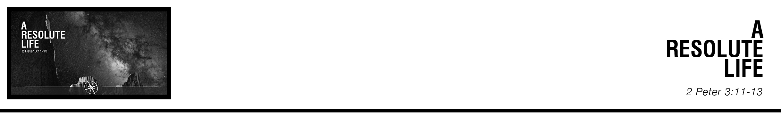Description: confused 02

***11*** *Since all these things are thus to be dissolved, what sort of people ought you to be in lives of holiness and godliness,*

***12*** *waiting for and hastening the coming of the day of God, because of which the heavens will be set on fire and dissolved, andthe heavenly bodies will melt as they burn!****13*** *But according to his promise we are waiting for new heavens and a*

*new earth in which righteousness dwells.*  (ESV)

PJ Berner • Compass Bible Church • December 30 & 31, 2017 • Msg. # G17-14

**1. Get ______________________________________** (v.11)

**2. Evangelize ______________________________** (v.12)

**3. Hope ____________________________** (v.13)

**Application Questions**

*These questions are provided for your further study and application of today’s sermon. Thoughtfully writing out the answers to these questions will help to drive home the point of today’s study. It is also helpful when you are able to discuss your answers with others. For more information about small groups at Compass Bible Church that utilize these questions as the basis for their weekly discussion, please call the church office at (949) 540-0699 or email us at SmallGroups@CompassChurch.org.*

1. How often do you contemplate the return of Christ and the judgment that will follow? Peter’s instructions would seem to make it imperative that we not neglect to consider these things. Read **Revelation 22:12**; **Romans 14:10-12**; **1 Corinthians 3:11-15** and **2 Corinthians 5:9-10**. How might spending more time pondering texts like these impact the way you live?

2. Are you eager for Jesus to return? If not, why not? What are the things that are keeping you anchored to this world?

3. In 2 Peter 3:9, Peter declares that the Lord wishes that none should perish, but that all should reach repentance. God is sovereign over the salvation of the lost, but read **Romans 10:14-15**. Considering this verse and **2 Peter 3:12**, how should you play a role in seeing more people come to repentance? Why can’t we just sit back and trust God to save the elect?

*This Week’s  
Bible Reading Schedule*

**December 31st**

*Mal.1-4 & Rev.22*

**January 1st**

*Gen.1-2 & Mt.1*

**January 2nd**

*Gen.3-5 & Mt.2*

**January 3rd**

*Gen.6-8 & Mt.3*

**January 4th**

*Gen.9-11 & Mt.4*

**January 5th**

*Gen.12-14 & Mt.5:1-26*

**January 6th**

*Gen.15-17 & Mt.5:27-48*

**January 7th**

*Gen.18-19 & Mt.6*

*2*

4. How can you specifically hasten the return of Christ by evangelizing the unbelievers in your life? Who specifically can you resolve to pursue this year with the gospel? Ask others to hold you accountable to be faithful to share the gospel with them.

5. As you think about the return of Christ what are some of the aspects of the new heavens and new earth that you are most looking forward to?