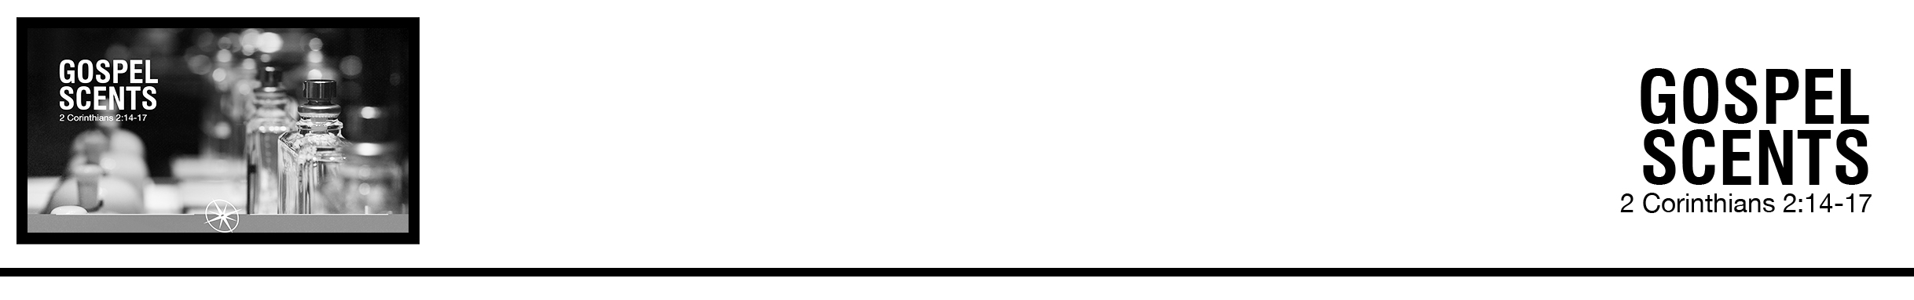Description: confused 02

***14*** *But thanks be to God, who in Christ always leads us in triumphal procession, and through us spreads the fragrance of the knowledge of him everywhere.*

***15*** *For we are the aroma of Christ to God among those who are being saved and among those who are perishing,*

***16****to one a fragrance from death to death, to the other a fragrance from life to life. Who is sufficient for these things?****17*** *For we are not, like so many, peddlers of God’s word, but as men of sincerity, as commissioned by God, in the sight of God we speak in* *Christ.*  (ESV)

PJ Berner • Compass Bible Church • June 30 & July 1, 2018 • Msg. # G18-05

**1. Live ________________________________** (v.14a)

**2. Publicize ______________________________** (vv.14b-16a)

**3. Faithfully ___________________________** (vv.16b-17)

**Application Questions**

*These questions are provided for your further study and application of today’s sermon. Thoughtfully writing out the answers to these questions will help to drive home the point of today’s study. It is also helpful when you are able to discuss your answers with others. For more information about small groups at Compass Bible Church that utilize these questions as the basis for their weekly discussion, please call the church office at (949) 540-0699 or email us at SmallGroups@CompassChurch.org.*

1. Read **1 Corinthians 6:20** and **Philippians 3:12**. What are some practical implications of Christ’s ownership over you? Why is it necessary for us to daily be reminded of this aspect of our identity as believers?

2. Read through the Beatitudes in **Matthew 5:2-12**. How are each of these paradoxical to what the world values? How do we see our identity as slaves of Christ represented in this passage?

3. **Acts 1:8** and **Matthew 28:19-20** are familiar texts to many, and they complement the idea of spreading the knowledge of Christ as seen in this weekend’s passage. Who are you specifically witnessing to and sharing the gospel with? What opportunities have you had recently to spread the aroma of Christ? What will it look like practically this week for you to spread the knowledge of Christ everywhere you go?

4. Read **1 Corinthians 1:17** and **2:1-2**. How can “words of eloquent wisdom” and “lofty speech” end up emptying the cross of its power? How are you tempted toward this error in your evangelism? What are we betraying about our confidence in God to save when we rely on human wisdom and eloquence in our evangelistic efforts?

*This Week’s  
Bible Reading Schedule*

**July 1st**

*Job 21-22 & Ac.10:1-23*

**July 2nd**

*Job 23-25 & Ac.10:24-48*

**July 3rd**

*Job 26-28 & Ac.11*

**July 4th**

*Job 29-30 & Ac.12*

**July 5th**

*Job 31-32 & Ac.13:1-23*

**July 6th**

*Job 33-34 & Ac.13:24-52*

**July 7th**

*Job 35-37 & Ac.14*

**July 8th**

*Job 38-39 & Ac.15:1-21*

*2*

5. Read **2 Corinthians 5:18-20**. Especially in verse 20, Paul uses some strong language (implore) to describe how we should be pleading with the lost in our lives to be saved. How does God use us — our personalities, our passion — to make his appeal to the lost? Does this in any way detract from the power of the gospel? How is this different from utilizing human wisdom and eloquence in our evangelism?