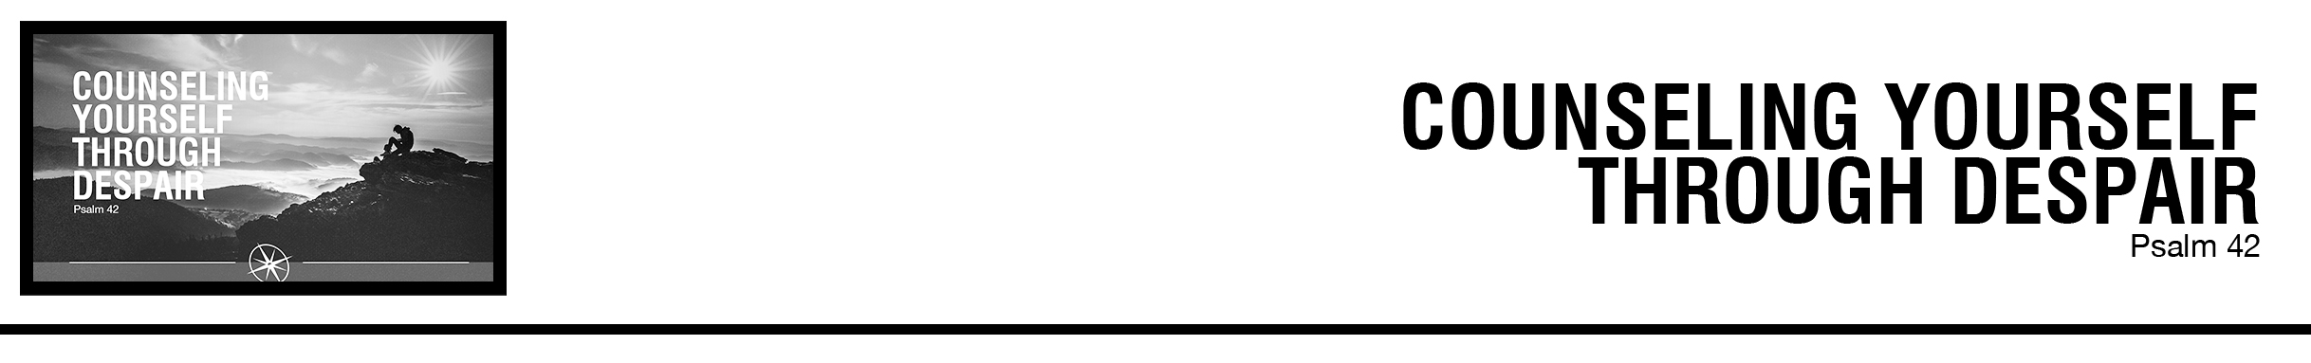Description: confused 02

***1*** *As a deer pants for flowing streams, so pants my soul for you, O God.*

***2*** *My soul thirsts for God, for the living God. When shall I come and appear before God?* ***3*** *My tears have been my food day and night, while they say to me all the day long, “Where is your God?”* ***4*** *These things I remember, as I pour out my soul: how I would go with the throng and lead them in procession to the house of God with glad shouts and songs of praise, a multitude keeping festival.* ***5*** *Why are you cast down, O my soul, and why are you in turmoil within me? Hope in God; for I shall again praise him, my salvation* ***6*** *and my God. My soul is cast down within me; therefore I remember you from the land of Jordan and of Hermon, from Mount Mizar.* ***7*** *Deep calls to deep at the roar of your waterfalls; all your breakers and your waves have gone over me.* ***8*** *By day the Lord commands his steadfast love, and at night his song is with me, a prayer to the God of my life.* ***9*** *I say to God, my rock: “Why have you forgotten me? Why do I go mourning because of the oppression of the enemy?”* ***10*** *As with a deadly wound in my bones, my adversaries taunt me, while they say to me all the day long, “Where is your God?”* ***11*** *Why are you cast down, O my soul, and why are you in turmoil within me? Hope in God; for I shall again praise him, my salvation and my God.* (ESV)

Rod Gomez • Compass Bible Church • July 28 & 29, 2018 • Msg. # G18-06

**1. Expect _________________________** (vv.1-3, 9-10)

**2. Recall __________________________** (vv.4, 6-8)

**3. Resolve ___________________________** (vv.5-6a, 11)

**Application Questions**

*These questions are provided for your further study and application of today’s sermon. Thoughtfully writing out the answers to these questions will help to drive home the point of today’s study. It is also helpful when you are able to discuss your answers with others. For more information about small groups at Compass Bible Church that utilize these questions as the basis for their weekly discussion, please call the church office at (949) 540-0699 or email us at SmallGroups@CompassChurch.org.*

1. Read **John 14:1-4** and **Revelation 21:1-7.** How can these passages provide comfort and endurance through depression or despair?

2. Read **1 Peter 4:12-14**. In what ways is it helpful and even encouraging to know that suffering is the expected reality for the Christian life?

3. Read **2 Corinthians 1:3-7** and **1 Peter 1:6-7.** Why are these passages critical to bear in mind as you endure trials and suffering?

4. Read **Psalm 1:1-3** and **Joshua 1:8.** Why should Christians make strong efforts to meditate on God’s truth, and how should this discipline impact the believer who is suffering?

5. Read **2 Corinthians 12:7-10**. What are some of the challenges you have experienced that have kept you dependent on Christ, and why was this better than if God had merely removed the challenges immediately after you prayed?

*This Week’s  
Bible Reading Schedule*

**July 29th**

*Ps.56-58 & Ac.28:1-15*

**July 30th**

*Ps.59-61 & Ac.28:16-31*

**July 31st**

*Ps.62-64 & Ro.1*

**August 1st**

*Ps.65-67 & Ro.2*

**August 2nd**

*Ps.68-69 & Ro.3*

**August 3rd**

*Ps.70-72 & Ro.4*

**August 4th**

*Ps.73-74 & Ro.5*

**August 5th**

*Ps.75-77 & Ro.6*

*2*

6. Read **Psalm 103:1-5**. Recount some of the myriad of ways in which God has faithfully provided for you through good times and bad.