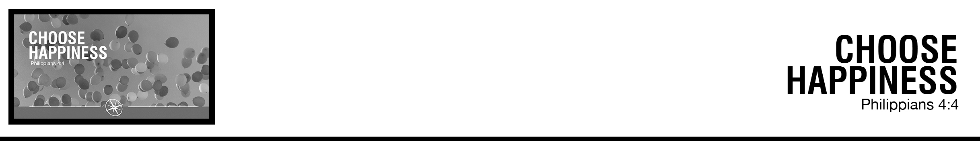Description: confused 02

***4*** *Rejoice in the Lord always; again I will say, rejoice.*  (ESV)

Philip De Courcy • Compass Bible Church • August 18 & 19, 2018 • Msg. # G18-09

**1. _________________________**

**2. ____________________________**

**3. _________________________**

**Application Questions**

*These questions are provided for your further study and application of today’s sermon. Thoughtfully writing out the answers to these questions will help to drive home the point of today’s study. It is also helpful when you are able to discuss your answers with others. For more information about small groups at Compass Bible Church that utilize these questions as the basis for their weekly discussion, please call the church office at (949) 540-0699 or email us at SmallGroups@CompassChurch.org.*

1. Discuss the difference between superficial happiness and solid joy in Christ.

2. In what sense and to what degree is happiness a choice? Is joy more than an emotion?

3. How do we treasure Christ in the midst of tough circumstances?

4. How do we rejoice in the Lord? How do we make our souls happy in the Lord?

5. Discuss the three things [salvation, sovereignty and sufficiency] that fuel unmitigated joy in Christ.

*This Week’s  
Bible Reading Schedule*

**August 19th**

*Ps.112-115 & 1Cor.1*

**August 20th**

*Ps.116-118 & 1Cor.2*

**August 21st**

*Ps.119:1-48 & 1Cor.3*

**August 22nd**

*Ps.119:49-104 & 1Cor.4*

**August 23rd**

*Ps.119:105-176 & 1Cor.5*

**August 24th**

*Ps.120-123 & 1Cor.6*

**August 25th**

*Ps.124-127 & 1Cor.7:1-24*

**August 26th**

*Ps.128-131 & 1Cor.7:25-40*

*2*

6. Make a list of further reasons to rejoice.