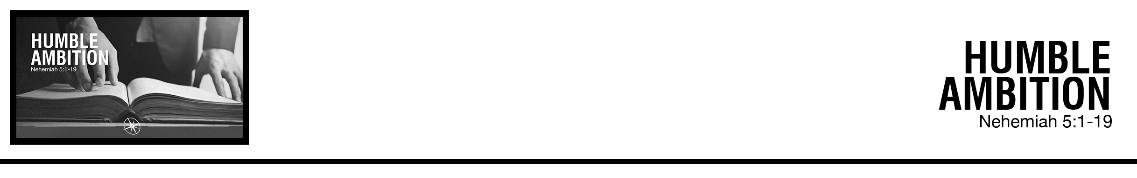Description: confused 02

Mike Elliott • Compass Bible Church • November 3 & 4, 2018 • Msg. # G18-10

**1. Embrace _________________________________**

**2. Guard ____________________________**

**3. Maintain __________________________**

**Application Questions**

*These questions are provided for your further study and application of today’s sermon. Thoughtfully writing out the answers to these questions will help to drive home the point of today’s study. It is also helpful when you are able to discuss your answers with others. For more information about small groups at Compass Bible Church that utilize these questions as the basis for their weekly discussion, please call the church office at (949) 540-0699 or email us at SmallGroups@CompassChurch.org.*

1. Read **Nehemiah 1:4-11**. How does this prayer reveal Nehemiah's ambition for God's glory? How can you utilize your prayer time to cultivate more humble ambition?

2. Read **Nehemiah 5:1-5** and **Acts 6:1-7**. Why can success in one area of ministry blind us to failure in another? How does having the right ambition help solve that blindness?

3. Read **Nehemiah 3:5** and **Philippians 2:1-4**. In what areas of your life do you find it hard to 'stoop to serve’? How will you fight against those feelings?

4. Read **Nehemiah 5:14-15**. How can you utilize your community to sacrifice ambitiously for the glory of God?

*This Week’s  
Bible Reading Schedule*

**November 4th**

*Jer.38-39 & Heb.1*

**November 5th**

*Jer.40-42 & Heb.2*

**November 6th**

*Jer.43-45 & Heb.3*

**November 7th**

*Jer.46-48 & Heb.4*

**November 8th**

*Jer.49-50 & Heb.5*

**November 9th**

*Jer.51-52 & Heb.6*

**November 10th**

*Lam.1-2 & Heb.7*

**November 11th**

*Lam.3-5 & Heb.8*

*2*

5. Read **Nehemiah 5:19** and **Hebrews 11:6**. Why is being motivated by future rewards not selfish, but glorifying to God? What are some ways that you can remind yourself about these future rewards?