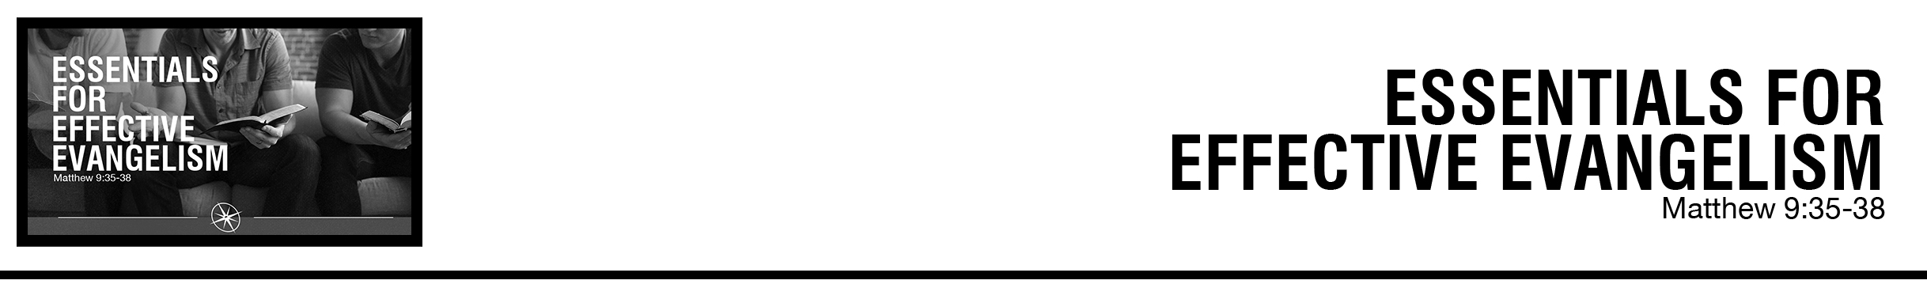Description: confused 02

***Matthew 9:35*** *And Jesus went throughout all the cities and villages, teaching in their synagogues and proclaiming the gospel of the kingdom and healing every disease and every affliction.*

***36*** *When he saw the crowds, he had compassion for them, because they were harassed and helpless, like sheep without a shepherd.* ***37*** *Then he said to his disciples, “The harvest is plentiful, but the laborers are few;*

***38*** *therefore pray earnestly to the Lord of the harvest to send out laborers into his harvest.”* (ESV)

Rod Gomez • Compass Bible Church • November 24 & 25, 2018 • Msg. # G18-11

**1. See ____________________________** (v.36)

**2. Replicate ___________________________** (v.35)

**3. Prioritize ______________________** (vv.37-38)

**Application Questions**

*These questions are provided for your further study and application of today’s sermon. Thoughtfully writing out the answers to these questions will help to drive home the point of today’s study. It is also helpful when you are able to discuss your answers with others. For more information about small groups at Compass Bible Church that utilize these questions as the basis for their weekly discussion, please call the church office at (949) 540-0699 or email us at SmallGroups@CompassChurch.org.*

1. Read **2 Corinthians 3:14** and **4:3-4**. What does Scripture say is the cause of people’s rejection of the gospel and what effect should that have on our thoughts, feelings, and actions toward the lost?

2. Read **1 Corinthians 2:1-5**. Noting Paul’s disposition among the Corinthians in v.3, what are some great-sounding reasons why Christians choose to exclude themselves from the work of evangelism, and which one(s) do you personally find most difficult to overcome? In what ways might this passage comfort you as you engage in evangelism?

3. What are some ways you might be able to create gospel-sharing opportunities in your life, work, or other social activities? Think of as many practical ways to accomplish this as you can and pick a few to begin putting into practice this week.

*This Week’s  
Bible Reading Schedule*

**November 25th**

*Ezk.34-35 & 1Pt.2*

**November 26th**

*Ezk.36-37 & 1Pt.3*

**November 27th**

*Ezk.38-39 & 1Pt.4*

**November 28th**

*Ezk.40 & 1Pt.5*

**November 29th**

*Ezk.41-42 & 2Pt.1*

**November 30th**

*Ezk.43-44 & 2Pt.2*

**December 1st**

*Ezk.45-46 & 2Pt.3*

**December 2nd**

*Ezk.47-48 & 1Jn.1*

*2*

4. Read **Revelation 21:8**, **2 Thessalonians 1:8-9**, **Matthew 13:40-42** and **Luke 12:4-5**. Drawing from the verses you just read, how would you explain the doctrine of hell to someone who doesn’t have a church background? What role should hell have in our evangelism?

5. Visit [https://www.compasschurch.org](https://www.compasschurch.org/) and re-familiarize yourself with our [Missionary Partners](https://www.compasschurch.org/missions/%20), our [church plants](https://www.compasschurch.org/), and [Compass 20/20](https://www.compasschurch.org/compass-2020/). Then, read **2** **Thessalonians 3:1-2** and **Colossians 4:2**. What strategies could you employ to ensure that you’re praying more frequently for the furtherance of the gospel both locally and abroad?