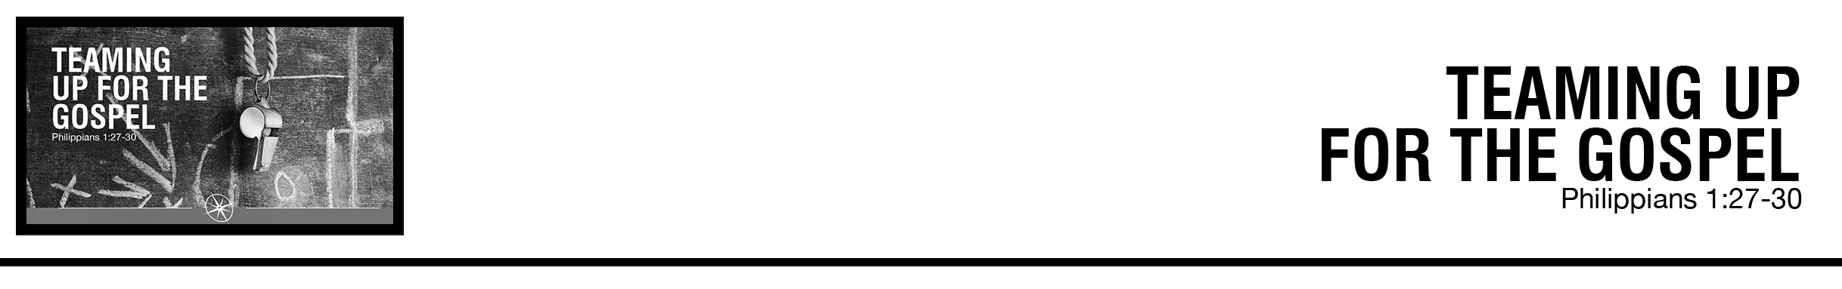Description: confused 02

John Fabarez • Compass Bible Church • October 5 & 6, 2019 • Msg. # G19-10

***Philippians 1:27*** *Only*

*let your manner of life be worthy of the gospel of Christ, so that whether I come and see you or am absent, I may hear of you that you are standing firm in one spirit, with one mind striving side by side for the faith of the gospel,* ***28*** *and not frightened in anything by your opponents. This is a clear sign to them of their destruction, but of your salvation, and that from God.* ***29*** *For it has been granted to you that for the sake of Christ you should not only believe in him but also suffer for his sake,* ***30*** *engaged in the same conflict that you saw I had and now hear that I still have.* (ESV)

**1. Be _________________________________** (vv.28-30)

**2. Find ___________________________________** (v.27b)

**3. Don’t _________________________________** (v.27a)

**Application Questions**

*These questions are provided for your further study and application of today’s sermon. Thoughtfully writing out the answers to these questions will help to drive home the point of today’s study. It is also helpful when you are able to discuss your answers with others. For more information about small groups at Compass Bible Church that utilize these questions as the basis for their weekly discussion, please call the church office at (949) 540-0699 or email us at SmallGroups@CompassChurch.org.*

1. Read **1 Peter 4:12-16.** What kinds of suffering should and should not be a part of living for and representing Christ in our world?

2. Read **Matthew 5:10-12**. How do these words of Jesus change your perspective on exclusion, insults, and persecution? How and why should this affect your boldness to share the gospel this week?

3. Read **1 Corinthians 1:10** and **Ephesians 4:25-32**. Local churches are warned to avoid “divisions” that splinter congregations. How might you contribute to the problem of disunity? How can you become a part of the solution?

4. Read **Acts 5:40-42**. What strength do you derive from other Christians that motivates you to share the gospel boldly?

*This Week’s  
Bible Reading Schedule*

**October 6th**

*Is.34-36 & Phil.2*

**October 7th**

*Is.37-38 & Phil.3*

**October 8th**

*Is.39-40 & Phil.4*

**October 9th**

*Is.41-42 & Col.1*

**October 10th**

*Is.43-44 & Col.2*

**October 11th**

*Is.45-47 & Col.3*

**October 12th**

*Is.48-49 & Col.4*

**October 13th**

*Is.50-52 & 1Th.1*

5. Read **2 Timothy 2:20-26**. What is the link between holy living and successful evangelism? Describe the kind of person that represents the gospel well.