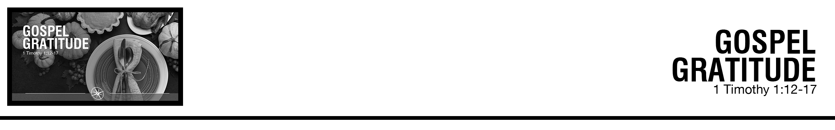Description: confused 02

***1Timothy 1:12*** *I thank him who has given me strength, Christ Jesus our Lord, because he judged me faithful, appointing me to his service,* ***13*** *though formerly I was a blasphemer, persecutor, and insolent opponent. But I received mercy because I had acted ignorantly in unbelief,*

***14*** *and the grace of our Lord overflowed for me with the faith and love that are in Christ Jesus.* ***15*** *The saying is trustworthy and deserving of full acceptance, that Christ Jesus came into the world to save sinners, of whom I am the foremost.* ***16*** *But I received mercy for this reason, that in me, as the foremost, Jesus Christ might display his perfect patience as an example to those who were to believe in him for eternal life.* ***17*** *To the King of the ages, immortal, invisible, the only God, be honor and glory forever and ever. Amen.* (ESV)

PJ Berner • Compass Bible Church • November 30 & December 1, 2019 • Msg. # G19-11

**1. Daily ________________________________** (vv.12-13)

**2. Humbly _______________________________** (vv.14-15)

**3. Realize __________________________________** (vv.16-17)

**Application Questions**

*These questions are provided for your further study and application of today’s sermon. Thoughtfully writing out the answers to these questions will help to drive home the point of today’s study. It is also helpful when you are able to discuss your answers with others. For more information about small groups at Compass Bible Church that utilize these questions as the basis for their weekly discussion, please call the church office at (949) 540-0699 or email us at SmallGroups@CompassChurch.org.*

1. Read **1 Timothy 1:16**. Paul is magnifying God’s mercy by appealing to himself as the foremost of sinners. Is there a sliding scale of God’s mercy based on the wickedness of the sinner? Do you need less of God’s mercy than someone who had a more sinful background before Christ?

2. Read **Titus 2:11-13**. What are some additional aspects of God’s grace that we find in this passage for which we can be thankful?

3. **1 Timothy 1:12-17** is basically Paul’s testimony. What are some of the more powerful testimonies you have read or heard? What makes them so powerful? Where do you see the power of God at work in your own testimony?

4. Read **Hebrews 12:1**. How can your testimony be an example to other Christians as well as to unbelievers?

*This Week’s  
Bible Reading Schedule*

**December 1st**

*Ezk.45-46 & 2Pt.3*

**December 2nd**

*Ezk.47-48 & 1Jn.1*

**December 3rd**

*Dan.1-2 & 1Jn.2*

**December 4th**

*Dan.3-4 & 1Jn.3*

**December 5th**

*Dan.5-6 & 1Jn.4*

**December 6th**

*Dan.7-8 & 1Jn.5*

**December 7th**

*Dan.9-10 & 2Jn.*

**December 8th**

*Dan.11-12 & 3Jn.*