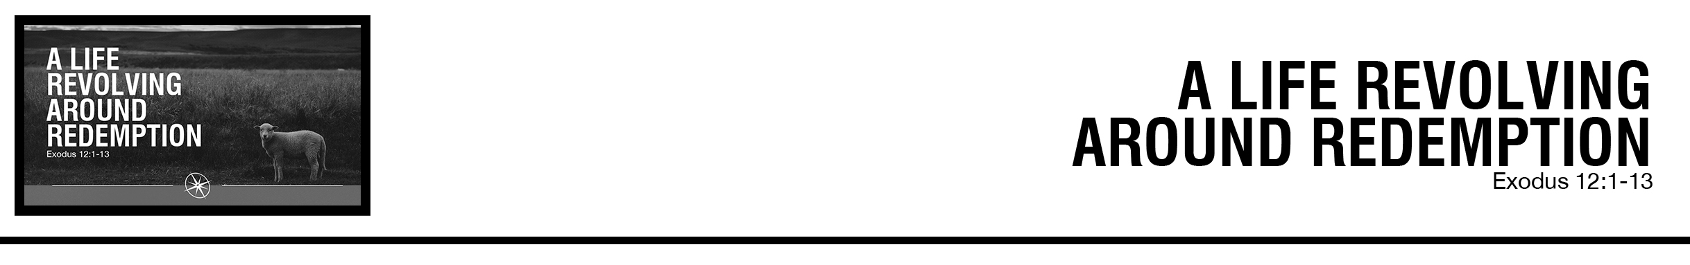Description: confused 02

***Exodus 12***

***1****The Lord said to Moses and Aaron in the land of Egypt,****2****“This month shall be for you the beginning of months. It shall be the first month*

*of the year for you.****3*** *Tell all the congregation of Israel that on the tenth day of this month every man shall take a lamb according to their fathers’ houses, a lamb for a household.****4****And if the household is too small for a lamb, then he and his nearest neighbor shall take according to the number of persons; according to what each can eat you shall make your count for the lamb.****5****Your lamb shall be without blemish, a male a year old. You may take it from the sheep or from the goats,****6****and you shall keep it until the fourteenth day of this month, when the whole assembly of the congregation of Israel shall kill their lambs at twilight.* ***7*** *“Then they shall take some of the blood and put it on the two doorposts and the lintel of the houses in which they eat it.*

***8*** *They shall eat the flesh that night, roasted on the fire; with unleavened bread and bitter herbs they shall eat it.****9****Do not eat any of it raw or boiled in water, but roasted, its head with its legs and its inner parts.* ***10****And you shall let none of it remain until the morning; anything that remains until the morning you shall burn.****11****In this manner you shall eat it: with your belt fastened, your sandals on your feet, and your staff in your hand. And you shall eat it in haste.  It is the Lord’s Passover.* ***12****For I will pass through the land of Egypt that night, and I will strike all the firstborn in the land of Egypt, both man and beast; and on all the gods of Egypt I will execute judgments: I am the Lord.****13****The blood shall be a sign for you, on the houses where you are. And when I see the blood, I will pass over you, and no plague will befall you to destroy you, when I strike the land of Egypt.* (ESV)

Abner Chou • Compass Bible Church • January 18 & 19, 2020 • Msg. # G20-01

***NOTES:***

**Application Questions**

*These questions are provided for your further study and application of today’s sermon. Thoughtfully writing out the answers to these questions will help to drive home the point of today’s study. It is also helpful when you are able to discuss your answers with others. For more information about small groups at Compass Bible Church that utilize these questions as the basis for their weekly discussion, please call the church office at (949) 540-0699 or email us at SmallGroups@CompassChurch.org.*

1. What did you learn about the nature of the law in the Old Testament in this week’s sermon?  How does that help us to rightly interpret and understand its application today?

2. In light of the fact that Passover was the centerpiece of Israel’s calendar, what can you do to ensure that the gospel is the centerpiece of your schedule?

3. In the Old Testament, the Passover was the uniting factor for Israel’s families and relationships. How can the gospel serve that same function in your fellowship and relationships with other Christians?

4. What did you learn in this sermon about the way the Passover displays the doctrine of redemption, and why are those truths so important to keep in mind?

*This Week’s  
Bible Reading Schedule*

**January 19th**

*Gen.44-45 & Mt.14:1-21*

**January 20th**

*Gen.46-48 & Mt.14:22-36*

**January 21st**

*Gen.49-50 & Mt.15:1-20*

**January 22nd**

*Ex.1-3 & Mt.15:21-39*

**January 23rd**

*Ex.4-6 & Mt.16*

**January 24th**

*Ex.7-8 & Mt.17*

**January 25th**

*Ex.9-10 & Mt.18:1-20*

**January 26th**

*Ex.11-12 & Mt.18:21-35*

5. List a few newfound insights about the Passover and the gospel.  What specifically will you do this week to pass on these insights to your friends, children, or grandchildren?